Willian Bernatzki Woellner

30021175

Testing Documentation

AT2

Table of Contents

Application Testing Documentation 1

Screenshots 3

# Application Testing Documentation

|  |  |  |  |  |
| --- | --- | --- | --- | --- |
| **Test Case** | **Description** | **Expected Result** | **Actual Result** | **Comments** |
| 1. Create a new user following the rules | Create a new admin. The password must have a minimum of 1 uppercase letter, 1 lowercase letter, 1 number, and 8 characters. | A new user created using the rules. | The password must be encrypted and the email must be verified to not be duplicated. | Ref. Figure 1  Ref. Figure 2  Ref. Figure 3 |
| 2. Rate a Movie | Select a movie and rate it | A movie rated from 1 to 5 stars. | Message: movie not found can be displayed using white color.  The last rating is not saved when I rated a movie 2 times. | Ref. Figure 4  Ref. Figure 5  Ref. Figure 6 |
| 3. Top 10 Movies Rated | Show a chart with the top 10 movies rated | The top 10 movies rated must be displayed on a chart. | As expected | Ref. Figure 7 |
|  |  |  |  |  |
|  |  |  |  |  |
|  |  |  |  |  |
|  |  |  |  |  |
|  |  |  |  |  |

# Screenshots

Figure 1

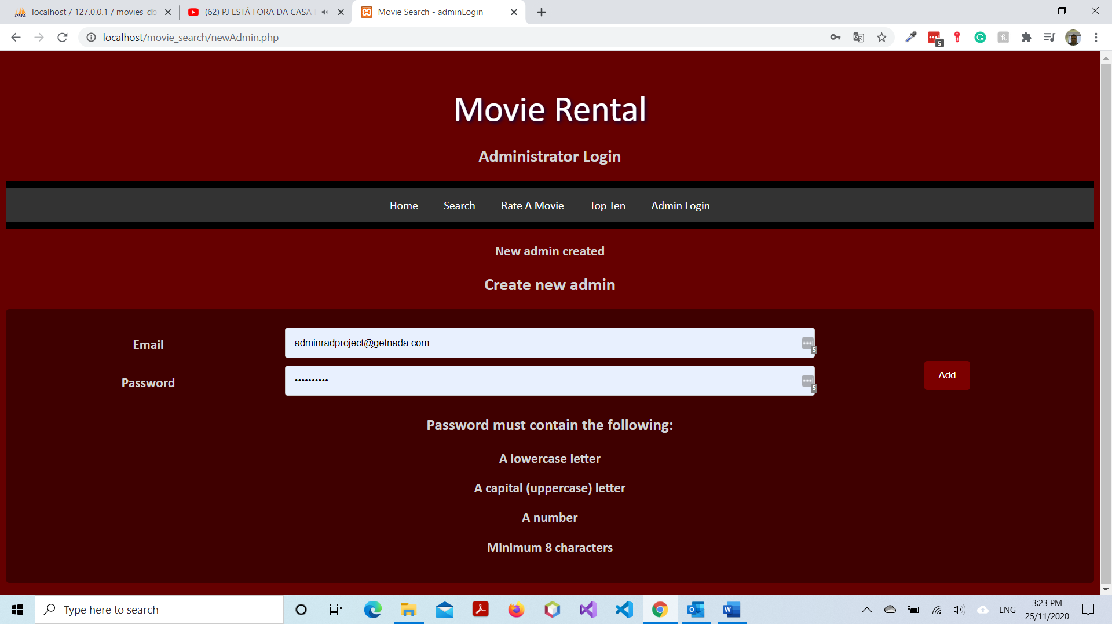

Figure 2

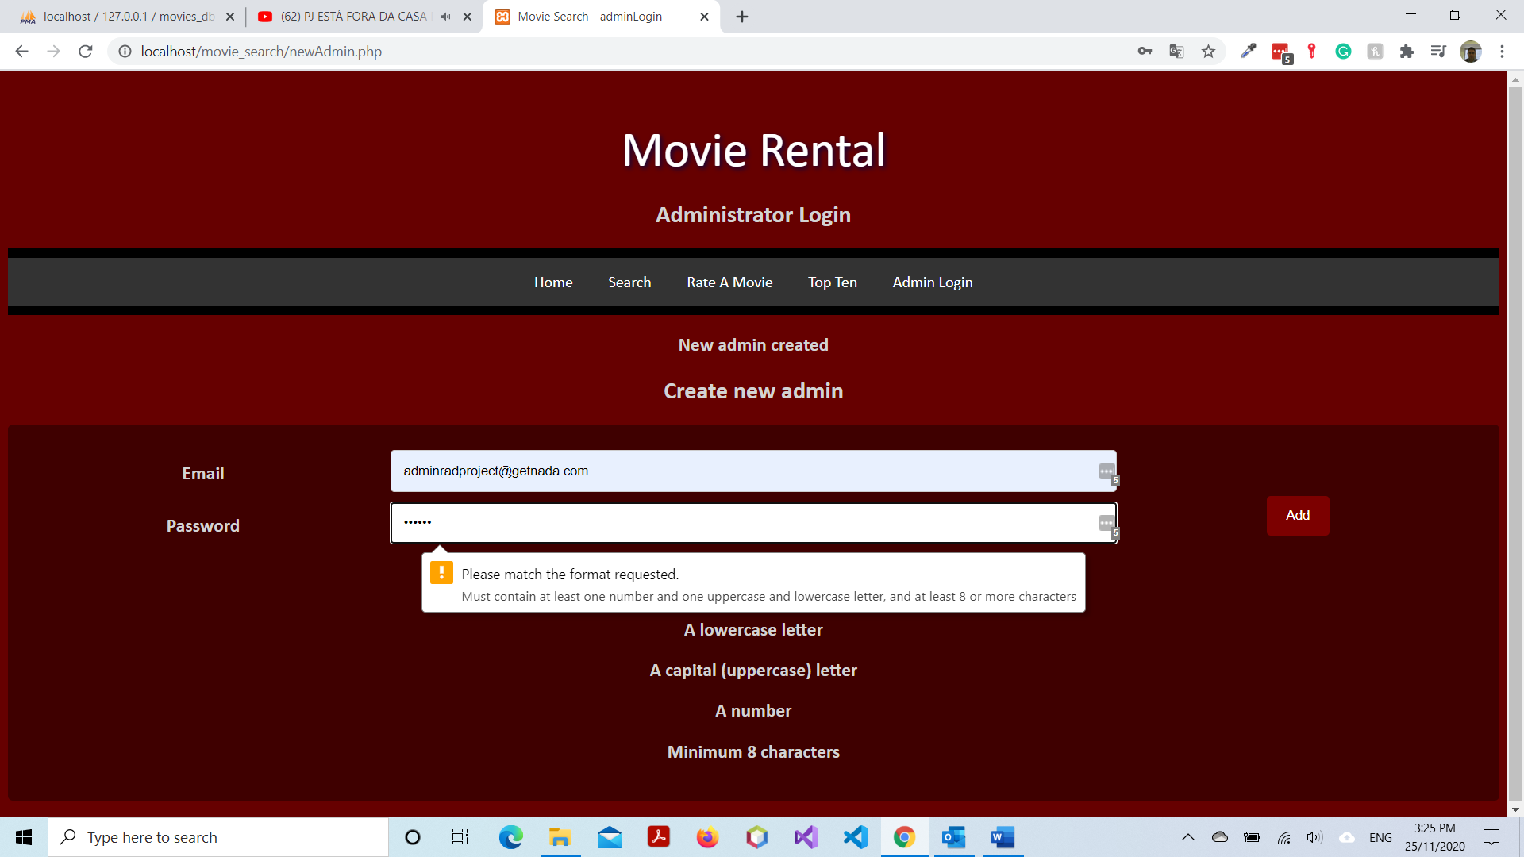

Figure 3

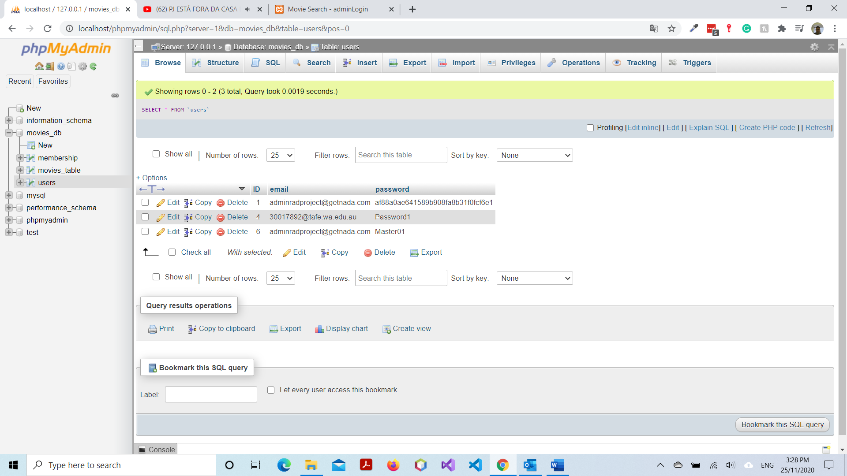

Figure 4

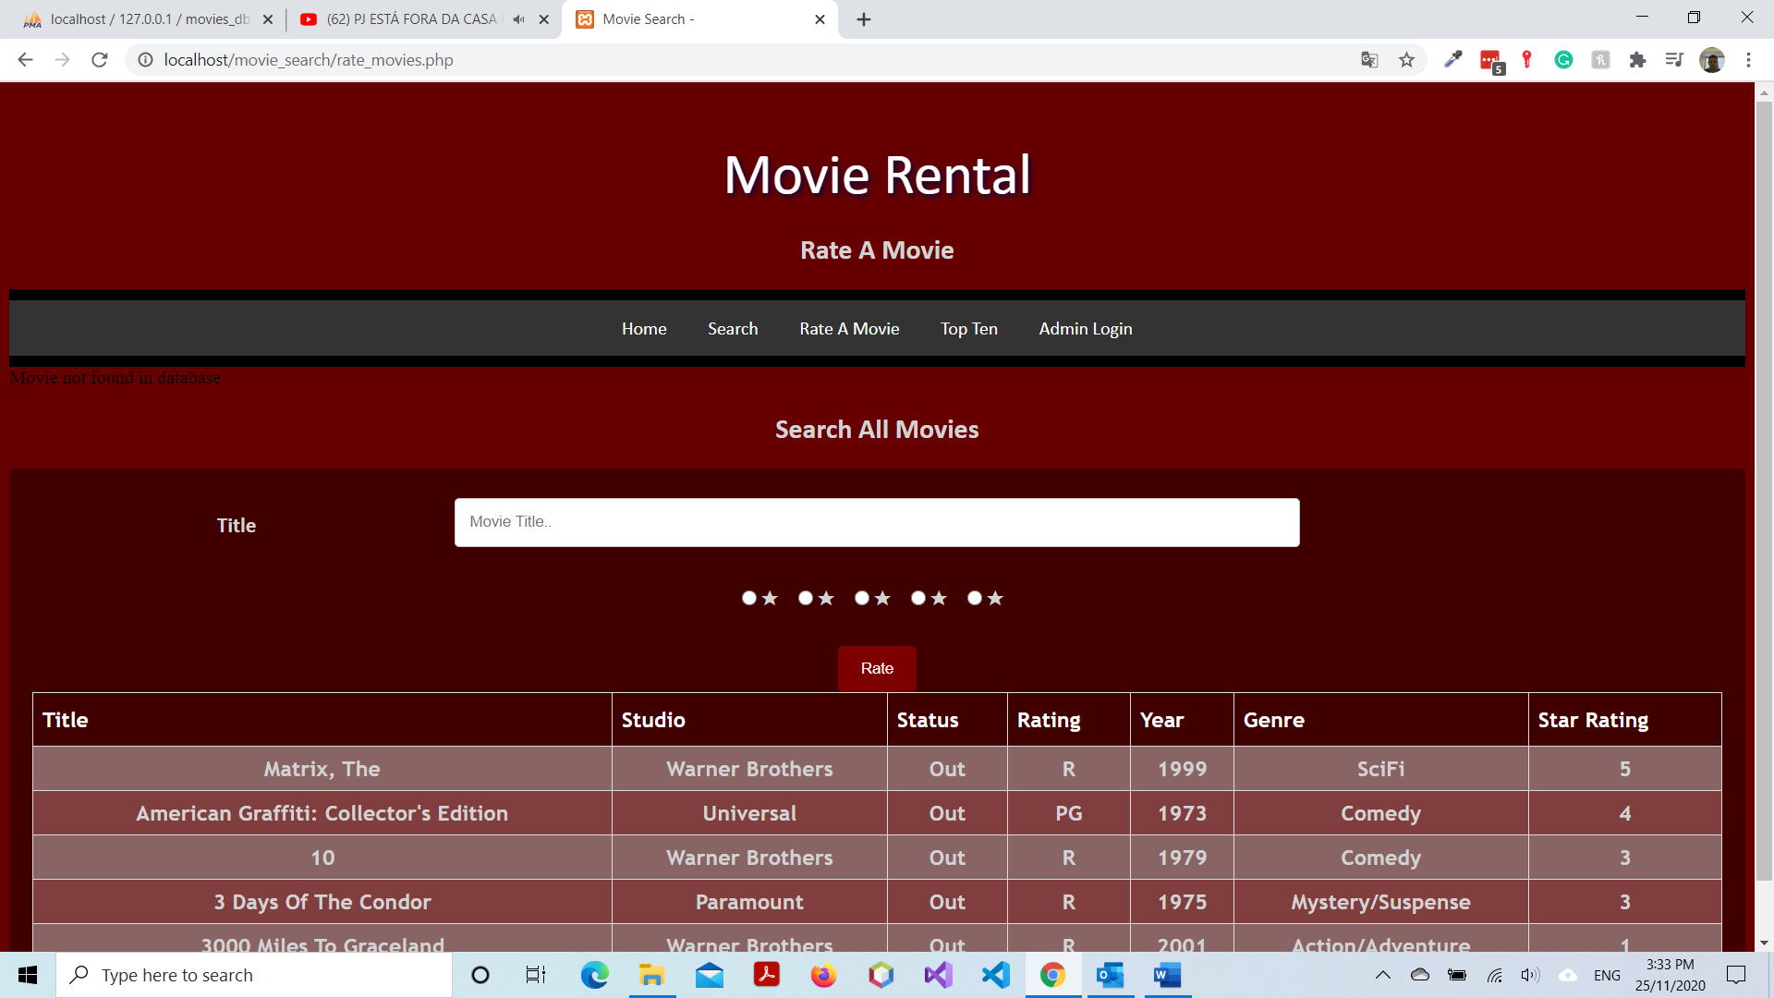

Figure 5

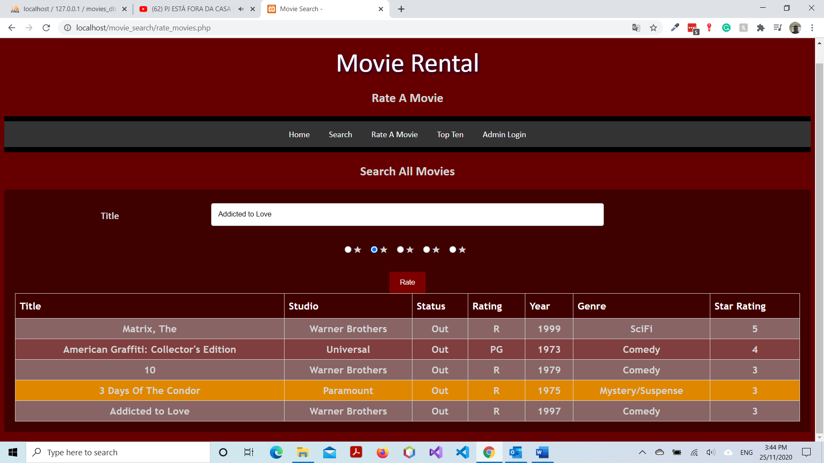

Figure 6



Figure 7

